
TDI SQL Capstone Project Documentation
Name: Felicitas Ezechikeluba
Track: Data Analytics
Cohort: Sapphire
Tool: SQL

1. Title
TDI SQL Capstone Project: Product and Sales Performance Analysis for Maven Toys Retail Stores
DASHBOARD
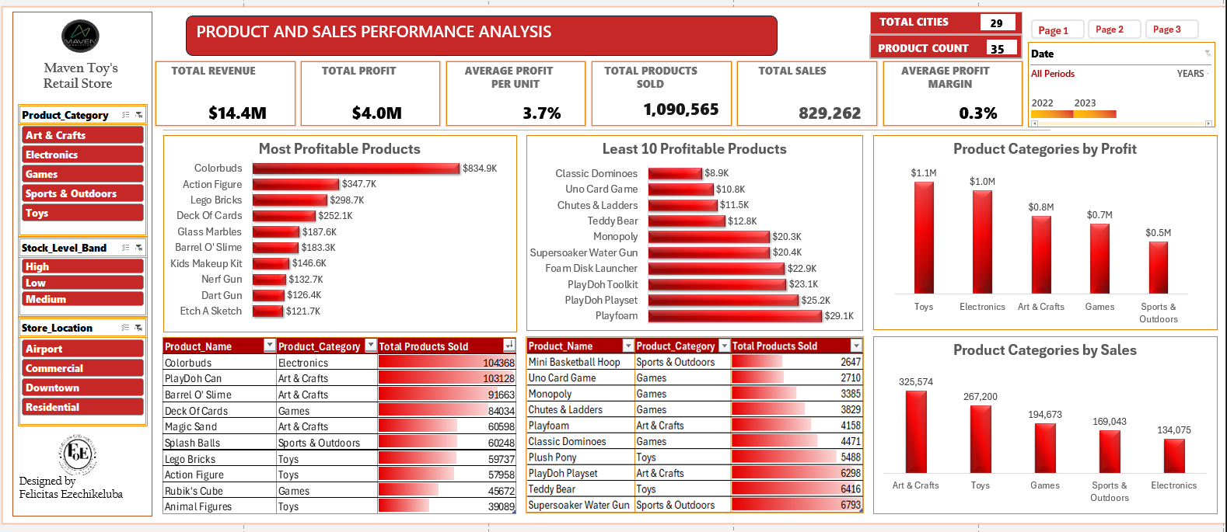
1.1. Abstract
This project aims to generate actionable insights by analyzing product, sales, inventory, and store data from a fictitious retail chain called Maven Toys, which operates four toy stores across 29 cities in Mexico.
The dataset includes detailed information about products, store locations, daily transactions, and current inventory levels. The goal is to identify top-performing and underperforming products, understand sales trends over time, and explore the factors influencing product performance.
The methodology involved cleaning the data, merging the Products, Sales, Inventory, and Stores tables, and conducting an exploratory data analysis using SQL.
The results reveal key revenue drivers, slow-moving products, and patterns in demand based on time and location. These insights can guide better decisions around inventory planning, pricing strategies, and promotional efforts to boost overall sales and profitability.
1.2. Project Overview

This project analyzes product, sales, inventory, and store data from a fictitious Mexican toy retail chain, Maven Toys, which operates four stores across 29 cities. It explores the relationship between product performance, sales trends, and operational factors such as location, inventory levels, and store longevity. By integrating data from four key sources—Products, Sales, Inventory, and Stores—the project aims to uncover patterns that explain which products drive revenue, which underperform, and how seasonal or regional dynamics impact demand. The goal is to provide insights that support smarter inventory planning, pricing, and promotional decisions to improve profitability.

1.3. Introduction
Background
This project focuses on analyzing sales, product, inventory, and store data from a fictional toy retail chain called Maven Toys. As businesses rely more on data to guide their decisions, this analysis aims to uncover useful insights that can help improve sales and inventory planning. By working with multiple connected tables, I explored product performance, seasonal sales trends, and how store location or age might affect results. The goal is to give a full picture of what drives sales and how the business can grow more effectively.
1.4. Problem Statement
The retail store offers a wide range of products but lacks clear visibility into which items drive sales and which consistently underperform. This gap limits effective inventory planning and hinders revenue growth.
This analysis will identify top-selling products, highlight underperforming items, and examine the factors contributing to poor performance. The insights will help the store make informed decisions about stocking, pricing, and promotions to boost sales and profitability.
Ultimately, the goal is to understand:
What factors are influencing product and Sales performance?
The factors considered in this analysis are based on available column details across the tables. These include seasonality (days and months), store location, product category, product demand/popularity, brand familiarity, pricing, and whether the store is well-known or well-established.
1.5. Objectives
- Analyze revenue and profit trends across products, categories, and stores.
- Identify top-selling and underperforming products to improve inventory planning.
- Explore time-based patterns (daily, monthly, seasonal) to guide pricing, stocking, and promotion strategies.
- Measure product performance drivers such as price, location, and category.
- Investigate inventory levels to find products that are overstocked or selling slowly.
- Understand how store age, location, and product category influence performance.
1.5.1 Key Focus Areas
The product is the focus of this analysis, with sales used to measure its performance. Each table provides supporting data to help explain how products are performing.
- The product is the central unit of analysis.
- Sales is the dependent variable.
- Each table (Inventory, Stores, Sales, Calendar) supports explaining product performance.
1.6. Data Description
This retail dataset is based on a fictional toy store chain, Maven Toys, operating in 29 cities across Mexico. The project uses four main tables:
- Products Data: Contains information about each product, including name, category, cost, and retail price.
- Stores Data: Provides store-level details such as store name, city, exact location, and opening date.
- Inventory Data: Shows the quantity of each product available in each store.
- Sales Data: Records daily sales transactions, including the date, store, product sold, units sold, and sales price.
In simple terms, this dataset allows us to:
- Understand product performance over time and across store locations
- Monitor stock levels and identify slow-moving products
- Track sales trends and total revenue
- Compare product cost vs. retail pricing
- Evaluate store performance based on location and years of operation
1.7. Data Source
The dataset was sourced from Maven Analytics, a reputable platform that offers publicly available, high-quality datasets for real-world business analysis and data training purposes.
The data represents a fictional toy retail chain and includes sales, products, inventory, and store information across various cities in Mexico.
1.8. Data Collection
The datasets were obtained as CSV files from Maven Analytics.com Playground and imported into SQL for analysis.
1.9. Data Characteristics
The dataset is based on a fictitious toy retail chain in Mexico called Maven Toys. It contains structured data across four interconnected tables, capturing information about products, stores, daily transactions, and current inventory levels at each store location.
- Data Structure: Relational — organized across multiple tables
- Number of Records: 829,263
- Number of Fields: 19 columns across four main tables:
  - Products: Contains product names, categories, cost, and price
  - Stores: Includes store name, city, location, and opening date
  - Sales: Logs daily transactions, units sold, and transaction dates
  - Inventory: Tracks stock quantity by product and store
1.10. Methodology
The project followed a structured approach using SQL to explore and prepare the data for analysis and visualization:
- Data Cleaning: Checked for and handled missing values, duplicates, and data consistency issues
- Exploratory Data Analysis (EDA): Analyzed individual tables to understand patterns, relationships, and anomalies
- Data Merging: Joined the Sales, Products, Inventory, and Stores tables into a central table for easier querying
- Derived Fields: Calculated revenue, profit, profit margin, and extracted time-based elements (day, month, year)
- KPI Development: Defined key performance indicators to evaluate product and store performance
1.11. Statistical Analysis
- Computed total revenue, total profit, average profit per unit, and total products sold
- Analyzed product-level performance, identifying top-selling and underperforming items
- Explored seasonal and monthly sales trends
- Assessed store performance based on revenue, profit, and inventory movement
- Evaluated how store age, location, and product category influenced performance metrics
1.12. Analysis
Key Performance Indicators (KPI’s)
- What is the total revenue generated?- Essential for identifying product performance
- Total Profit- Shows how much value a product really delivers
- Avg Profit per Unit- Helps you see which products are more profitable per sale
- Total Products Sold- Measures product demand
- Average profit margin
- Total Sales
Key Business Questions Addressed
- Which products and categories drive the highest sales?
- Which products and categories drive the lowest sales?
- Which product categories drive the most and least sales?
- Which products generate the most profit?
- Which products generate the least profit?
- Which product categories are most and least profitable?
- Which products remain in inventory the longest?
- What are the monthly and seasonal sales trends?
- Which months have the highest and lowest product sales?
- Which days of the week record the highest number of transactions?
- Which stores sell the most products?
- Which store locations perform best in terms of product sales?
- Are certain stores more profitable based on how long they've been open?
- Which stores hold the highest stock levels, and are those products selling?
- Which stores generate the highest revenue and profit?
- Which cities record the highest sales volumes by product?
1.13. Approach
SQL queries were used to extract insights from the dataset. The analysis focused on revenue trends, product popularity, inventory levels, and geographical sales performance.

Key metrics such as total revenue, profit, product demand, and store performance were calculated by joining and analyzing multiple tables (Sales, Products, Stores, and Inventory).

Additional fields such as profit margin, years of store operation, and time-based breakdowns (day, month, year) were derived to support deeper exploration. This structured approach helped uncover patterns and answer the defined business questions efficiently.

2. Data Exploration and Cleaning
This step was carried out table by table to ensure the data was clean, consistent, and analysis ready. The checks included reviewing for missing values, duplicate rows, inconsistent data formats, and invalid or outlier entries.

2.1. Product Data
- Exploration:
A query was run to inspect all records in the MTD_products table.
- Null Checks:
Columns including Product_ID, Product_Name, Product_Category, Product_Cost, and Product_Price were checked for missing values.
Outcome: No null values were found.
- Duplicate Check:
Full row duplication was checked using all fields. Additionally, the Product_ID column was reviewed for uniqueness.
Outcome: No duplicate rows or duplicate product IDs were found.

2.2. Stores_Data
- Exploration:
The MTD_Stores table was reviewed to confirm the completeness and consistency of all records.
- Null Checks:
Key fields such as Store_ID, Store_Name, Store_City, Store_Location, and Store_Open_Date were examined.
Outcome: No missing values were found.
- Duplicate Check:
All records were checked for duplication based on store attributes.
- Outcome: No duplicates detected

2.3. Sales_Data
- Exploration and Null Checks:
The MTD_Sales table, which contains the largest number of records, was checked for missing entries in key fields: Sale_ID, Date, Store_ID, Product_ID, and Units.
Outcome: No null values found.
- Duplicate Check:
All columns were checked for repeated rows.
Outcome: No duplicate sales records found.
- Outlier Check:
Sales entries with negative Units were flagged as invalid.
Outcome: No such records were found.
- Indexing:
Given the size of this table and the frequency of queries involving Product_ID, an index was created on that column to improve query performance

2.4. Inventory_Data
- Exploration:
The MTD_Inventory table was inspected to ensure that stock quantities and relationships with stores and products were accurately captured.
- Null Checks:
Fields Store_ID, Product_ID, and Stock_On_Hand were examined for null values.
Outcome: No null values detected.
- Duplicate Check:
The table was checked for repeated entries of the same product in the same store with the same stock value.
Outcome: No duplicates found.
- Conclusion:
Across all four tables—Products, Stores, Sales, and Inventory—no major data quality issues were detected. The dataset is clean and reliable, making it suitable for further analysis.

3. Data Analysis
With the tables thoroughly explored and cleaned, the following KPI’s and business questions were asked:

-- Ques 1. What is the Total Revenue Generated?
(Revenue = Units Sold × Product Price)
SELECT SUM(s.Units * p.Product_Price) AS Total_Revenue
FROM [MTD_sales] s
JOIN [MTD_products] p ON s.Product_ID = p.Product_ID;

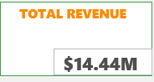

-- Ques 2. Total Profit
(Profit = (Price – Cost) × Units Sold)
SELECT SUM((p.Product_Price - p.Product_Cost) * s.Units) AS Total_Profit
FROM [MTD_sales] s
JOIN [MTD_products] p ON s.Product_ID = p.Product_ID;

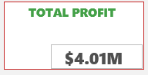

--Ques 3. Average Profit per Unit
SELECT
SUM((p.Product_Price - p.Product_Cost) * s.Units) * 1.0 / SUM(s.Units) AS Avg_Profit_Per_Unit
FROM [MTD_sales] s
JOIN [MTD_products] p ON s.Product_ID = p.Product_ID;

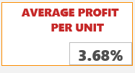

--Ques 4. Total Products Sold
(Total number of units sold)
SELECT SUM(Units) AS Total_Products_Sold
FROM [MTD_sales];
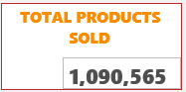

--Ques 5. Total Sales
SELECT COUNT(Sale_ID) AS Total_Sales
FROM [MTD_sales];

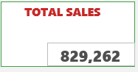
--Ques 6. Average Profit Margin
(Profit margin = (Price – Cost) / Price)
SELECT
AVG(CAST((p.Product_Price - p.Product_Cost) AS FLOAT) / NULLIF(p.Product_Price, 0)) AS Avg_Profit_Margin
FROM [MTD_products] p;
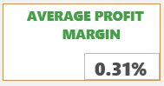

--Ques 7. What is the total count of distinct products being sold?
SELECT COUNT(DISTINCT Product_ID) AS Products_Count
FROM [MTD_sales];


--Ques 8. How many cities are there?
SELECT COUNT(DISTINCT Store_City) AS Total_Cities
FROM [MTD_stores];


--Ques 9. Which products and categories drive the highest sales?
SELECT TOP 10
p.Product_Name,
p.Product_Category,
SUM(s.Units) AS Total_Units_Sold
FROM [MTD_sales] s
JOIN [MTD_products] p ON s.Product_ID = p.Product_ID
GROUP BY p.Product_Category, p.Product_Name
ORDER BY Total_Units_Sold DESC;

--Ques 10. Which products and categories drive the lowest sales?
SELECT TOP 10
p.Product_Name,
p.Product_Category,
SUM(s.Units) AS Total_Units_Sold
FROM [MTD_sales] s
JOIN [MTD_products] p ON s.Product_ID = p.Product_ID
GROUP BY p.Product_Category, p.Product_Name
ORDER BY Total_Units_Sold ASC;

-- Ques 11. Which Product Categories drive the Most and Least sales?

SELECT
p.Product_Category,
SUM(s.Units) AS Total_Products_Sold
FROM
[dbo].[MTD_products] p
JOIN
[dbo].[MTD_sales] s ON p.Product_ID = s.Product_ID
GROUP BY
p.Product_Category
ORDER BY
Total_Products_Sold DESC; -- Change to ASC for Least Sales

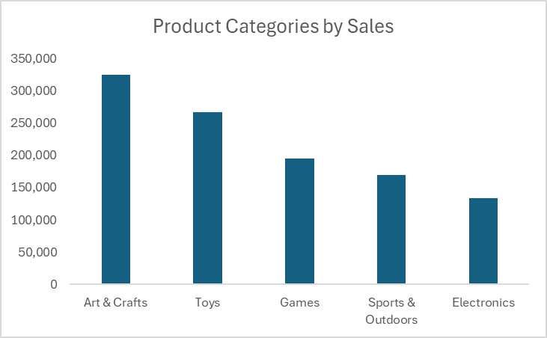

--Ques 12. Which products generate the most profit?
SELECT TOP 10
p.Product_Name,
SUM((p.Product_Price - p.Product_Cost) * s.Units) AS Total_Profit
FROM [MTD_sales] s
JOIN [MTD_products] p ON s.Product_ID = p.Product_ID
GROUP BY p.Product_Name
ORDER BY Total_Profit DESC;

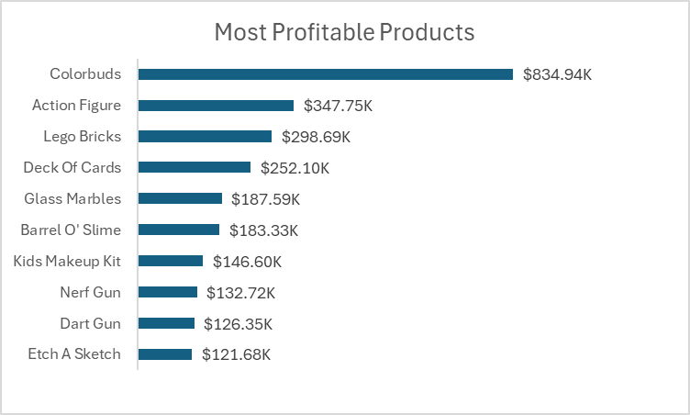

--Ques 13. Which products generate the least profit?
SELECT TOP 5
p.Product_Name,
SUM((p.Product_Price - p.Product_Cost) * s.Units) AS Total_Profit
FROM [MTD_sales] s
JOIN [MTD_products] p ON s.Product_ID = p.Product_ID
GROUP BY p.Product_Name
ORDER BY Total_Profit ASC;

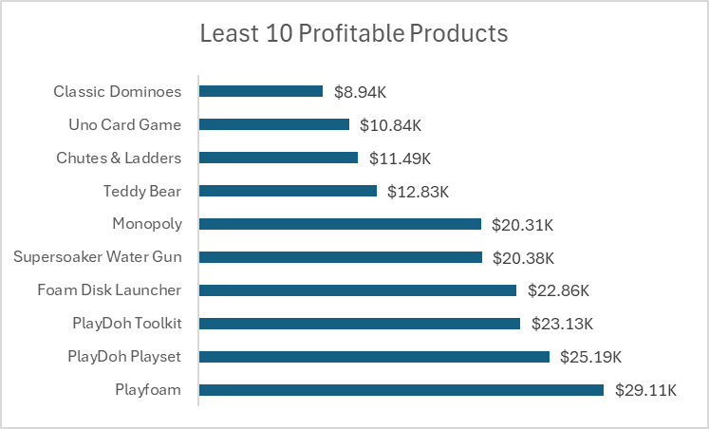

--Ques 14. Which product categories are most and least profitable?
SELECT
p.Product_Category,
SUM((p.Product_Price - p.Product_Cost) * s.Units) AS Category_Profit
FROM [MTD_sales] s
JOIN [MTD_products] p ON s.Product_ID = p.Product_ID
GROUP BY p.Product_Category
ORDER BY Category_Profit DESC;

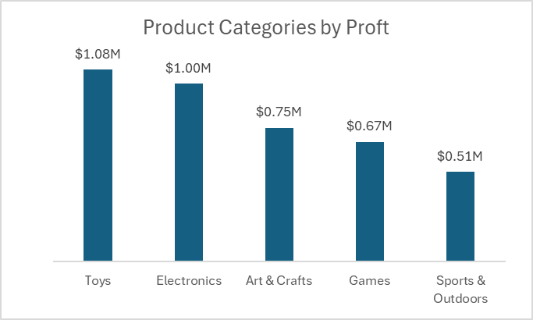

--Quest 15. Which products remain in inventory the longest?
SELECT TOP 10
p.Product_Name,
SUM(i.Stock_On_Hand) AS Total_Stock_On_Hand
FROM [MTD_inventory] i
JOIN [MTD_products] p ON i.Product_ID = p.Product_ID
GROUP BY p.Product_Name
ORDER BY Total_Stock_On_Hand DESC;

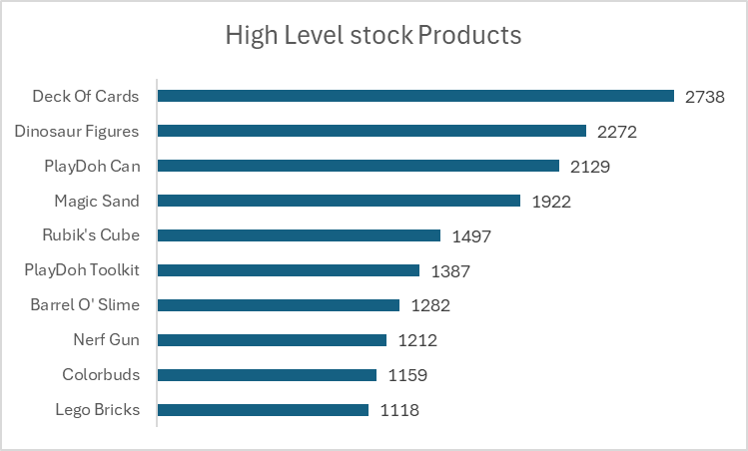

--Ques 16. What are the monthly and seasonal sales trends?
SELECT
YEAR(s.Date) AS Year,
MONTH(s.Date) AS Month,
SUM(s.Units) AS Monthly_Sales
FROM [MTD_sales] s
GROUP BY YEAR(s.Date), MONTH(s.Date)
ORDER BY Year, Month;

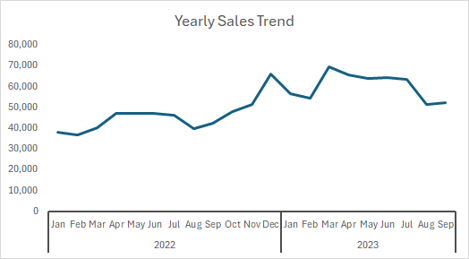

--Ques 17. Which months have the highest and lowest product sales?
SELECT
MONTH(s.Date) AS Month,
SUM(s.Units) AS Total_Sales
FROM [MTD_sales] s
GROUP BY MONTH(s.Date)
ORDER BY Total_Sales DESC;
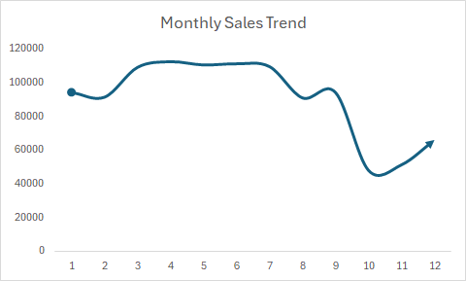
--Ques 18. Which days of the week record the highest number of transactions?
SELECT
DATENAME(WEEKDAY, s.Date) AS DayOfWeek,
COUNT(*) AS Transactions
FROM [MTD_sales] s
GROUP BY DATENAME(WEEKDAY, s.Date)
ORDER BY Transactions DESC;

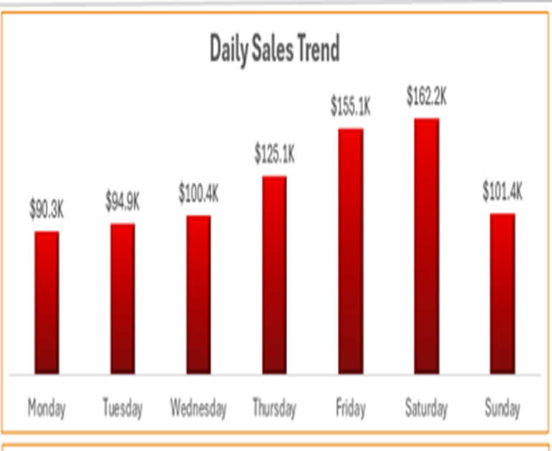

--Ques 19. Which stores sell the most products?
SELECT TOP 10
st.Store_Name,
SUM(s.Units) AS Total_Units_Sold
FROM [MTD_sales] s
JOIN [MTD_stores] st ON s.Store_ID = st.Store_ID
GROUP BY st.Store_Name
ORDER BY Total_Units_Sold DESC;
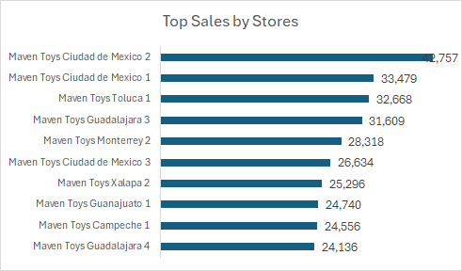

--Ques 20. Which store locations perform best in terms of product sales?
SELECT
st.Store_Location,
SUM(s.Units) AS Total_Units_Sold
FROM [MTD_sales] s
JOIN [MTD_stores] st ON s.Store_ID = st.Store_ID
GROUP BY st.Store_Location
ORDER BY Total_Units_Sold DESC;

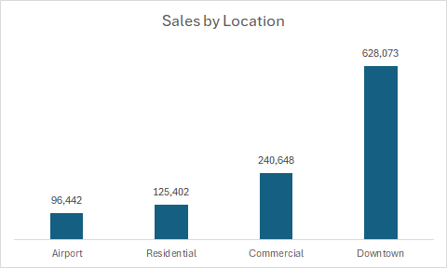

--Ques 21. Are certain stores more profitable based on how long they've been open?

-- Step 1: Calculate Years_Operating per store using MAX sale date
WITH Store_Age AS (
SELECT
st.Store_ID,
st.Store_Name,
DATEDIFF(YEAR, st.Store_Open_Date, MAX(s.Date)) AS Years_Operating
FROM MTD_sales s
JOIN MTD_stores st ON s.Store_ID = st.Store_ID
GROUP BY st.Store_ID, st.Store_Name, st.Store_Open_Date
)

-- Step 2: Join with product and sales data to calculate total profit
SELECT
sa.Store_Name,
sa.Years_Operating,
SUM((p.Product_Price - p.Product_Cost) * s.Units) AS Total_Profit
FROM MTD_sales s
JOIN MTD_products p ON s.Product_ID = p.Product_ID
JOIN Store_Age sa ON s.Store_ID = sa.Store_ID
GROUP BY sa.Store_Name, sa.Years_Operating;
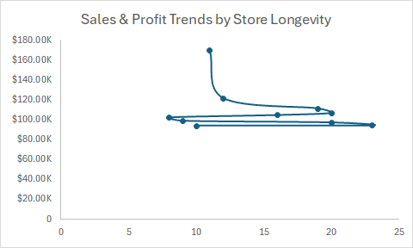

--Ques 22. Which stores hold the highest stock levels, and are those products selling?
SELECT
st.Store_Name,
st. Store_Id,
SUM(i.Stock_On_Hand) AS Stock_Level,
SUM(s.Units) AS Units_Sold
FROM [MTD_inventory] i
JOIN [MTD_stores] st ON i.Store_ID = st.Store_ID
JOIN [MTD_sales] s ON s.Store_ID = i.Store_ID AND s.Product_ID = i.Product_ID
GROUP BY st.Store_Name, st. Store_Id
ORDER BY Stock_Level DESC;
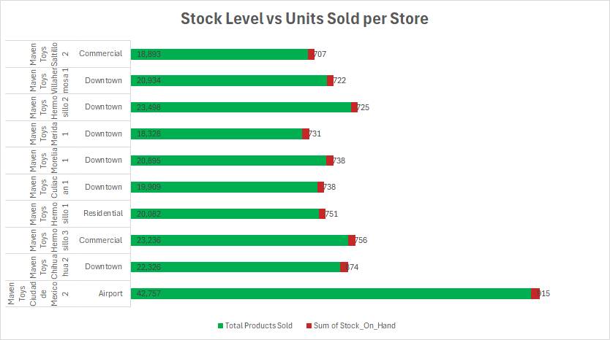

--Ques 23. Which stores generate the highest revenue and profit?
SELECT
st.Store_Name,
SUM(s.Units * p.Product_Price) AS Total_Revenue,
SUM((p.Product_Price - p.Product_Cost) * s.Units) AS Total_Profit
FROM [MTD_sales] s
JOIN [MTD_products] p ON s.Product_ID = p.Product_ID
JOIN [MTD_stores] st ON s.Store_ID = st.Store_ID
GROUP BY st.Store_Name
ORDER BY Total_Revenue DESC;
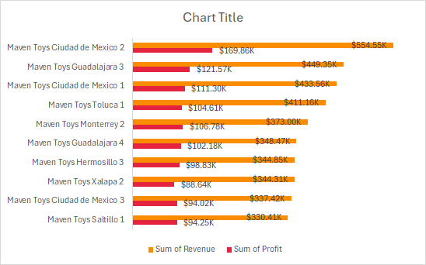

--Ques 24. Which cities record the highest sales volumes by product?
SELECT
st.Store_City,
SUM(s.Units) AS Total_Units_Sold
FROM [MTD_sales] s
JOIN [MTD_stores] st ON s.Store_ID = st.Store_ID
GROUP BY st.Store_City
ORDER BY Total_Units_Sold DESC;
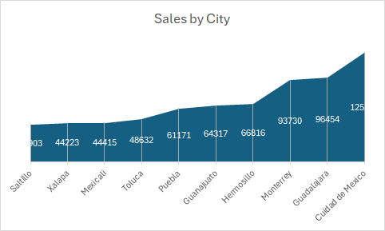

4. Summary of Findings
After analyzing the unified dataset and addressing the key business questions, several noteworthy insights have emerged:
Product Performance
- Top Products and Categories: Art & Crafts leads with high sales (325,574 units), driven by products like PlayDoh, Slime, and Magic Sand. Electronics has the top-selling product, Colorbuds, but the category overall has lower sales (134,075 units). Toys are strong (267,200 units), with products like Action Figures and Lego Bricks performing well. Games and Sports & Outdoors have moderate sales but don't lead in volume.
- Low Performers: Games dominate the bottom sellers (e.g., Uno, Monopoly), with Mini Basketball Hoop (Sports & Outdoors) being the lowest-selling product. Some Toys and Art & Crafts products, like Playfoam and PlayDoh Playset, also underperform, possibly due to low demand, visibility, or pricing issues.
- Profitability: Toys generate the highest profit ($1.08M), followed by Electronics ($1.00M, led by Colorbuds at $834.94K). Art & Crafts and Games have moderate profits ($0.75M and $0.67M), while Sports & Outdoors lags ($0.51M). Low-profit items like Classic Dominoes ($8.94K) and board games suggest low margins or weak demand.
- Inventory: High stock levels exist for products like Deck of Cards (2,738 units) and PlayDoh Can (2,129 units), which may indicate overproduction or seasonal demand mismatches. However, top-selling stores like Ciudad de Mexico 2 manage high stock effectively, showing good turnover.
Sales Insights
- Seasonality: Sales peak in Q2 (April–June, with April at 112,695 units) and December (66,031 units in 2022), driven by holiday and back-to-school seasons. October and November are the weakest months, possibly due to inventory or seasonal shifts. Saturday and Friday are the top sales days, while Monday and Tuesday are the lowest.
- Store Performance: Ciudad de Mexico 2 is the top store (42,757 units sold, $554.55K revenue, $169.86K profit), followed by Ciudad de Mexico 1 and Guadalajara 3. Downtown locations lead (628,073 units sold), while Airport and Residential stores trail. Store age doesn't always predict profit; newer stores like Ciudad de Mexico 2 outperform older ones.
- Location Impact: Ciudad de Mexico (125,599 units), Guadalajara, and Monterrey are top sales cities, likely due to large populations and strong retail infrastructure. Saltillo and Xalapa have the lowest sales, indicating room for growth.
- Other Factors: High-performing products like Colorbuds and Action Figures suggest strong brand familiarity and demand. Pricing strategies appear effective for profitable items, but low-profit products may need review. Well-known stores in urban areas drive sales, while less-established locations underperform.

5. Recommendations
Based on the findings from the data analysis, the following recommendations are suggested for strategic and operational improvements:
- Expand High-Performing Categories: Increase inventory and marketing for Art & Crafts and Toys, focusing on top sellers like PlayDoh, Slime, and Action Figures. Bundle Colorbuds with complementary products to boost Electronics sales.
- Address Low Performers: Reassess Games and Sports & Outdoors offerings. Consider discontinuing or rebranding low sellers like Mini Basketball Hoop and Classic Dominoes. Investigate pricing, visibility, or stock issues for underperforming Toys and Art & Crafts products.
- Optimize Inventory: Conduct a stock audit to address high inventory levels (e.g., Deck of Cards, PlayDoh Can). Improve demand forecasting to avoid overstock, especially for seasonal products.
- Leverage Peak Seasons: Launch promotions in Q2 (April–June) and November–December to capitalize on high sales periods. Use clearance sales or targeted campaigns in low months like October and February.
- Boost Weekend Sales: Increase staffing and promotions on Fridays and Saturdays. Introduce flash deals or events on Mondays and Tuesdays to lift early-week sales.
- Focus on Top Locations: Replicate successful strategies from Ciudad de Mexico 2 and Downtown stores in underperforming locations like Airport and Residential areas. Enhance marketing or adjust product mix in low-sales cities like Saltillo and Xalapa.
- Review Pricing and Costs: Analyze low-profit products for better pricing strategies or bundling. Investigate high-revenue, low-profit stores (e.g., Xalapa 2) for cost efficiencies to improve margins.

6. Conclusion
This analysis clearly reveals that the main drivers of sales and effective decision-making for growth and profitability in retail stores, as seen in this project, are product performance and pricing strategies. Prioritizing high-demand products within each category while targeting marketing efforts plays a significant role in improving results. Other factors influencing retail sales include seasonal trends and geographical location. Additionally, identifying inefficiencies and poor sales turnover through inventory management is both essential and beneficial for sustaining profitability.

